**CAR PRICE PREDICTION ANALYSIS**

CONTEXT

**OBJECTIVE:** To perform a comprehensive analysis on car-related data using Power BI to derive meaningful insights, mainly focusing on identifying trends, understand performance, relations, strategies, and other key factors that influence car prices to deliver informative observations and uncover opportunities in order to support data-driven decision-making.

**SCOPE:** The emphasis is purely on exploratory analysis and visual storytelling using Power BI. The analysis covers sales dataset focused within the,

* Visualizing distributions and relationships between features
* Identifying influential factors on car price
* Drawing insights from the trends observed in the dashboards
* Price variation based on car attributes (Brand, Model, Condition, etc.)
* Distribution of fuel types, transmissions, and engine sizes
* Mileage and year trends across different vehicle categories
* Outliers that may indicate unusual pricing or misreported features
* Potential predictors of price, helping support future price estimation models

**AUDIENCE:** This dashboard is intended for primary people like data analyst, sales manager, marketing teams, anyone analyzing price trends, customer on optimizing pricing strategy also business analysts, sales strategists, data enthusiasts seeking to understand the key drivers of car pricing. This dashboard will also be useful for:

* Dealers to make pricing decisions based on market patterns.
* Used Car sellers to assess fair pricing and avoid over or under valuation.
* Data Analysts to develop predictive models using relevant car attributes.
* Marketing teams to understand demand.

ANALYSIS

**DATA COLLECTION:** Dataset contains 2500 records of data contributing the collection of car related details like, Car ID, Brand – (Mercedes, Benz, Tesla, Audi, Ford, Toyota, Honda), Year – (2000 - 2023), Engine Size, Fuel Type – (Hybrid, Petrol, Electric, Diesel), Transmission – (Automatic, Manual), Mileage, Condition – (Used, New, Like New), Price, Models. Combination of Luxury, Economy Brands.

**DATA CLEANING: Cleaning process of this dataset includes,**

* Dataset checked for respective datatypes
* Duplicates are removed using Remove Duplicate option

Finally clean and clear dataset ready for analysis.

**DAX:** Data Analysis Expression, a library of functions and operators that can be combined to build formulas and expressions in Power BI for analysis.

**MEASURES:** Following Measures are created,

* Price - To calculate average, maximum and minimum Price
* Mileage - To calculate average, maximum and minimum Mileage
* Engine Size - To average Engine size
* Price by Brand - Average Price respect to each Brand
* Segregating Price and Count of car present in respective decade’s
* Average Price per Kilometre
* Count of cars – Transmission based

**CALCULATED COLUMN:** Following columns are added additionally,

* Recommendation - Relating Mileage and Price as,
* Price high and Mileage high - Least preferred
* Price high and Mileage low - Acceptable
* Price low and Mileage high - Considerable
* Price low and Mileage low – Highly preferred
* Brand category using custom column – Luxury, Economy Brand

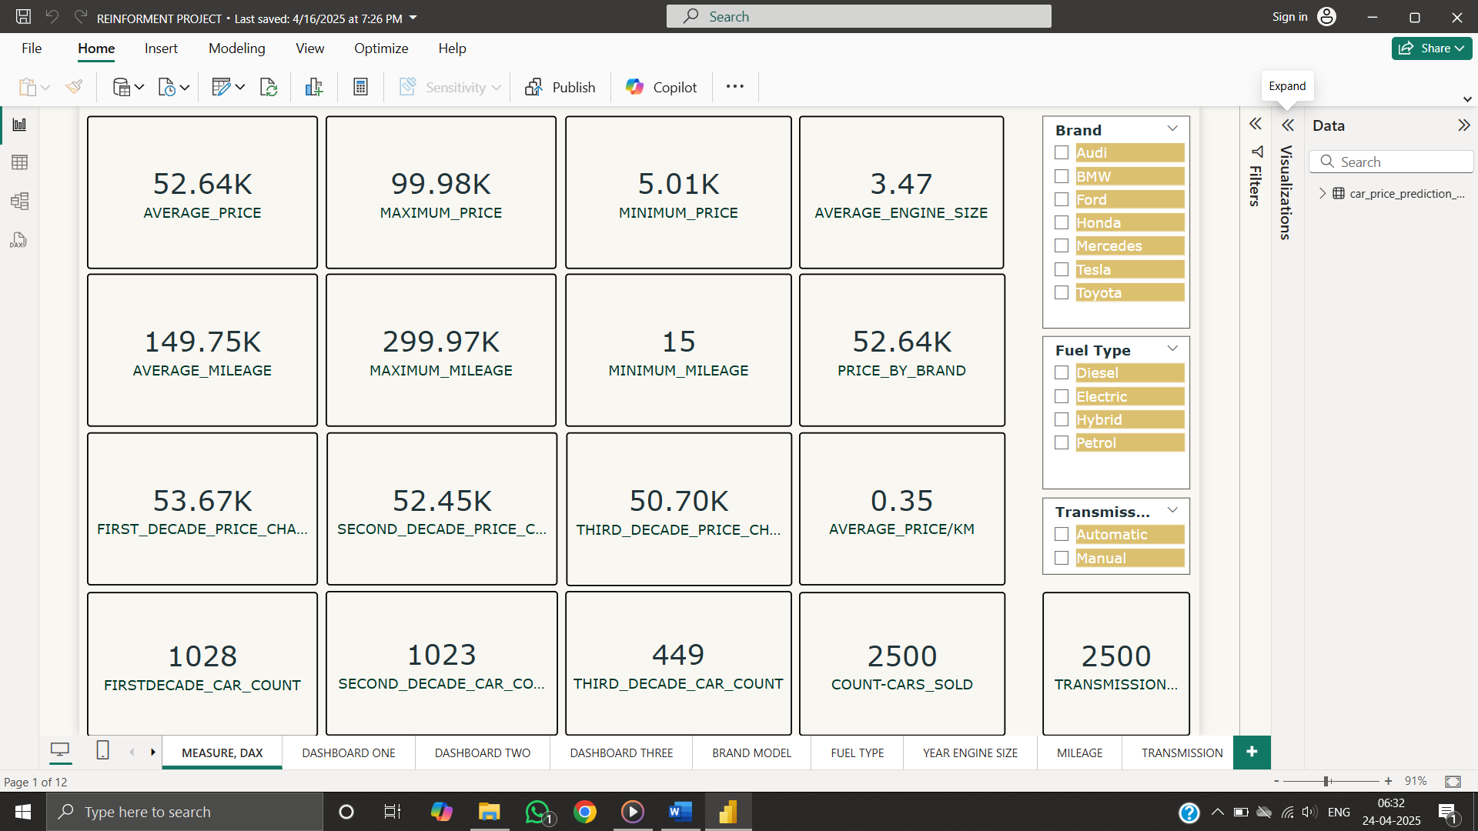

**ANALYSIS EXPLANATION:** In Power BI, the data - visualized through multiple dashboards, allowing for:

* PRICE-CAR COUNT-BRAND CATEGORY:

Analysis between brands segregated into two categories Luxury and Economy respect to price and count of cars in each brand, inferring that Luxury brand cars are higher in count and priced high compared to economy brand cars.

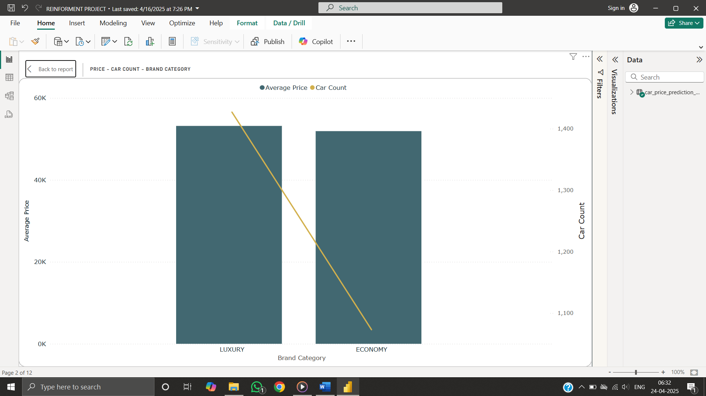

* PRICE-BRAND-TRANSMISSION:

Respect to price and brand the transmission part is analysed and found that each brand has a inverse relation between price and transmission like if the brand peaks price in automatic transmission cars then the price drops for manual cars inferring that if brand concentrates only one transmission type. Ford cars have equal concentration for both transmission leading to stability.

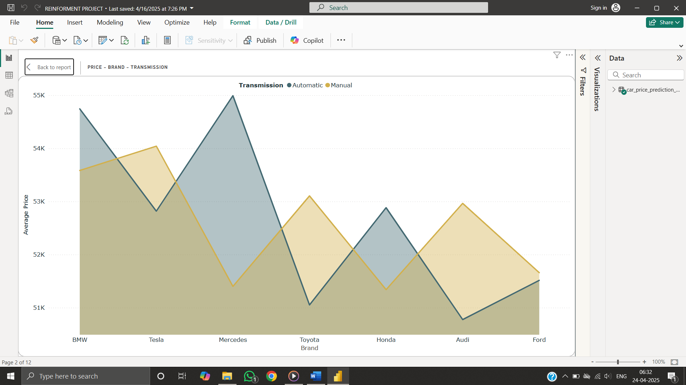

* PRICE-FUEL TYPE-CONDITION:

Comparing fuel type, price and condition, like new cars have higher pricing for deisel and hybrid engine and drops for petrol and electric vehicles follwed by new vehicles are priced high for petrol engine drops for hybrid, electric and deisel engine. Used cars have similar pricing for hybrid and petrol engine and priced high for electric vehicles.

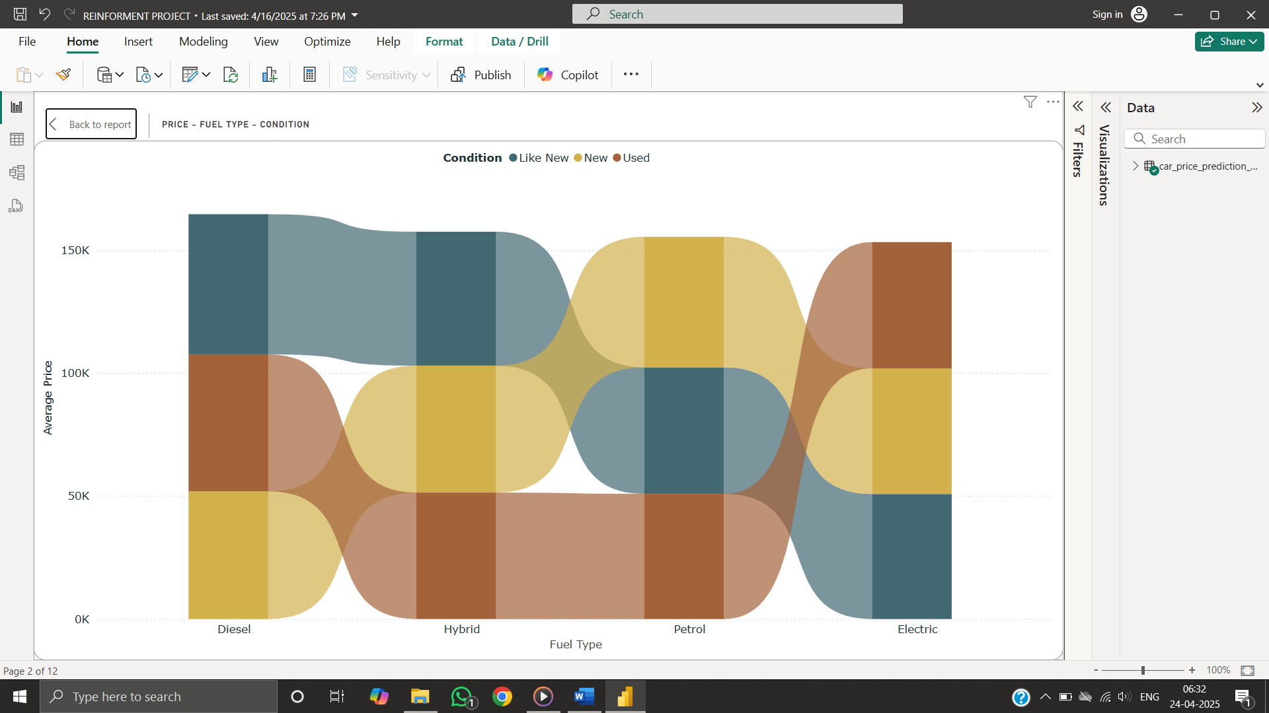

* PRICE-MODEL-BRAND:

Few Models like GLC, 3 Series, Camry, 5 Series from reputed brands like Mercedes, BMW, Toyota are priced high and prius, mustang, GLA from similar brands are priced low indicating price ranges between models in all brands.

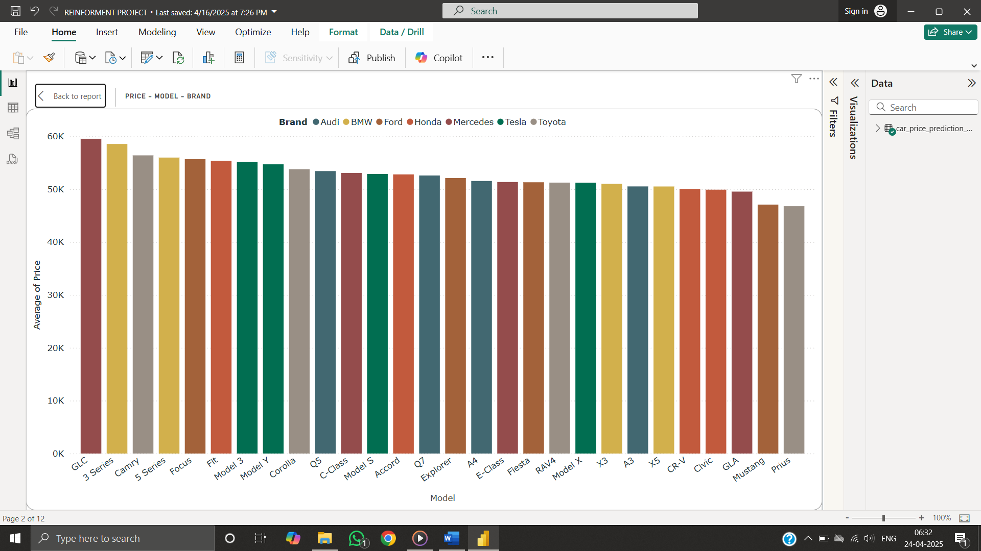

* PRICE-YEAR:

Price of cars with respect to year peaked at 2002, 2005 and 2012 with steap falls over the years and droped drastically in 2001 and in year 2020. Impact of pandemic is evident during the period 2020 and 2021 and there is a stable fall during the year 2008-2009. Overall the price has a steep ups and downs with no stabilization over a period.

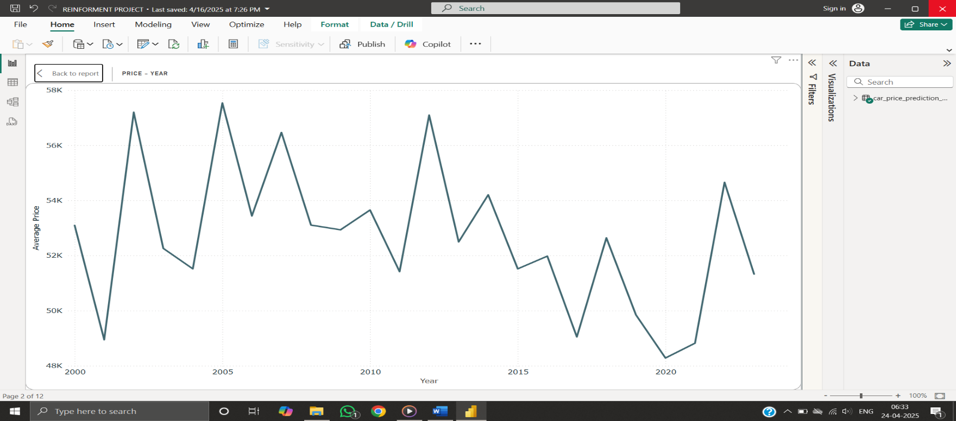

* PRICE-TRANSMISSION:

Price relating to transmission, inferring that the automatic transmission is priced slightly higher than mannual cars by a difference of about 50 thousand dollars. Concluding that people prefer mannual cars to automatic transmission irrespective of the technology improvements.

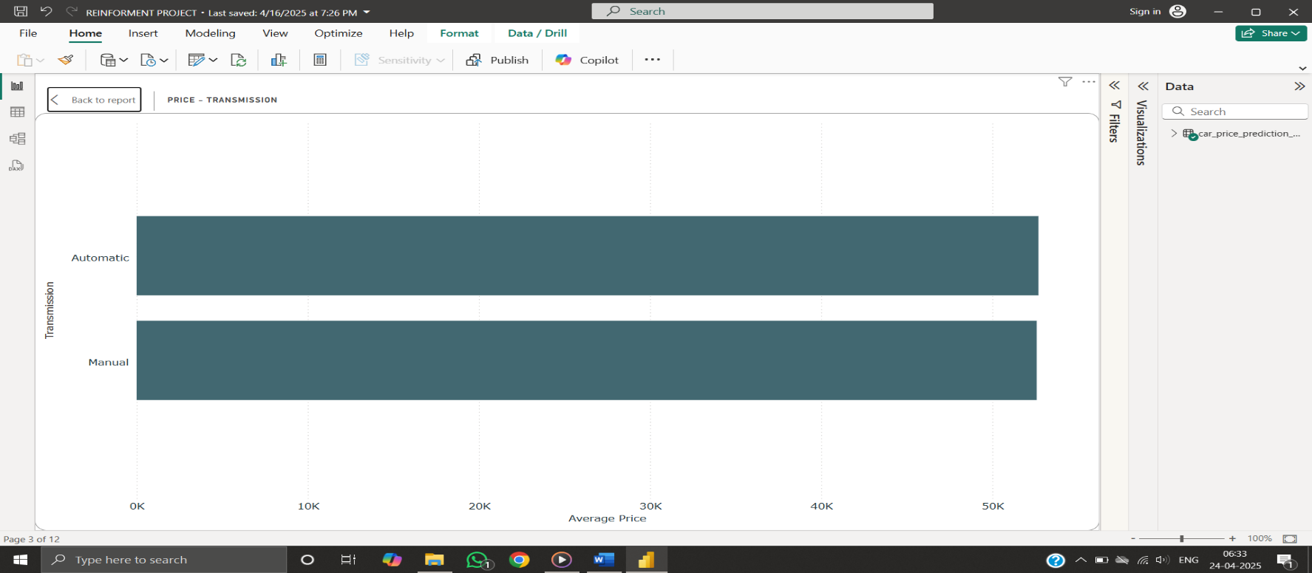

* PRICE-CONDITION-MILEAGE:

Comparing condition with average price and average mileage, Like New cars are priced high followed by used condition cars and New cars. Comparing the mileage Like New cars have massive mileage compared with used condition and new cars where used cars and new cars have similar average of mileage.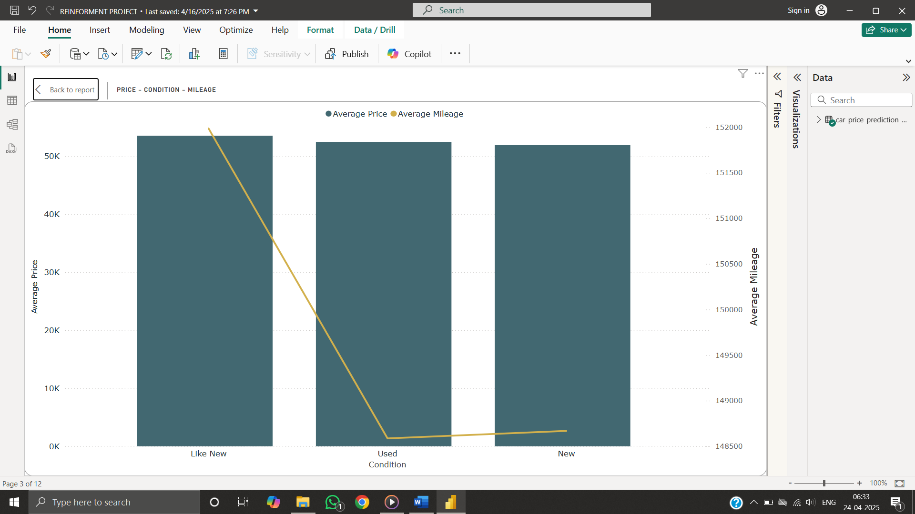

* MILEAGE-PRICE-BRAND:

Respect to mileage and price, brands like BMW and Tesla are showing that mileage and price are directly propotional where as Mercedes have a higher price for a relatively low mileage. Brands like toyota, honda, audi excibit a decent pricing for higher mileage. Ford stands out with relatively low pricing for higher mileage making it a better option for reliability.

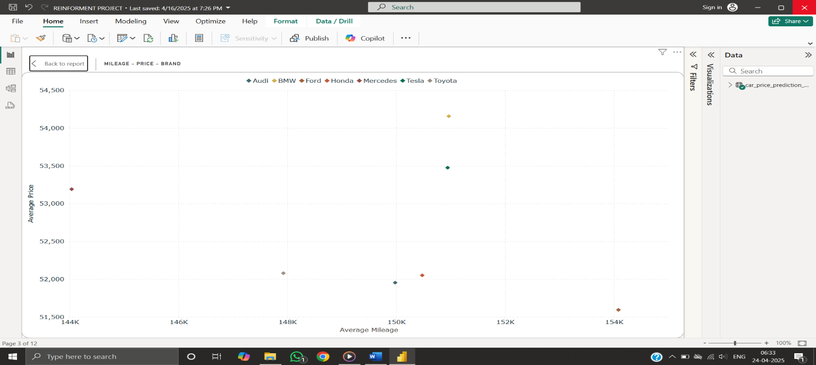

* MILEAGE-TRANSMISSION-FUEL TYPE:

Comparing transmission and fuel type with mileage, automatic transmission with hybrid engine has higher mileage compared to petrol, diesel engines and falls for manual transmission whereas, Petrol and diesel engine have an average mileage for automatic transmission and increase for manual transmission. Electrical engine has lower mileage for both automatic and manual transmission cars.

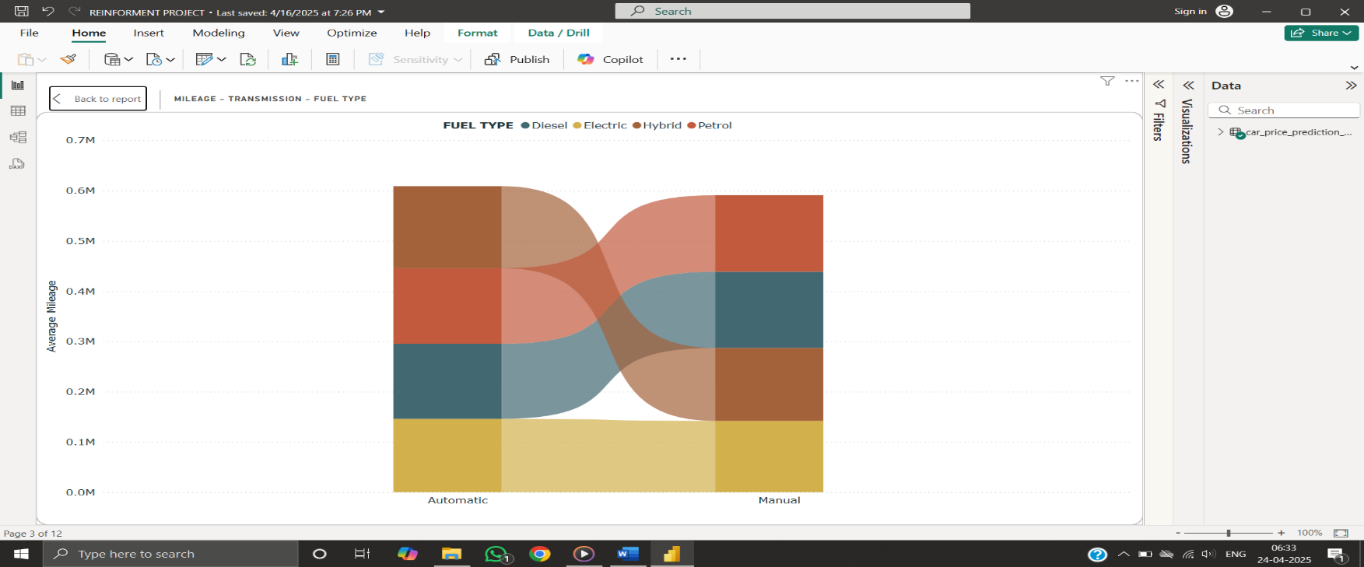

* PRICE-CONDITION-BRAND:

Comparing price, condition and brand, used cars have diverse price option by brand and Like New and New cars have similar average pricing around 50K$, where Tesla in Used cars, BMW in New and Tesla and Toyota in Like New cars are priced high on average. BMW has a standard pricing in all three categories by condition.

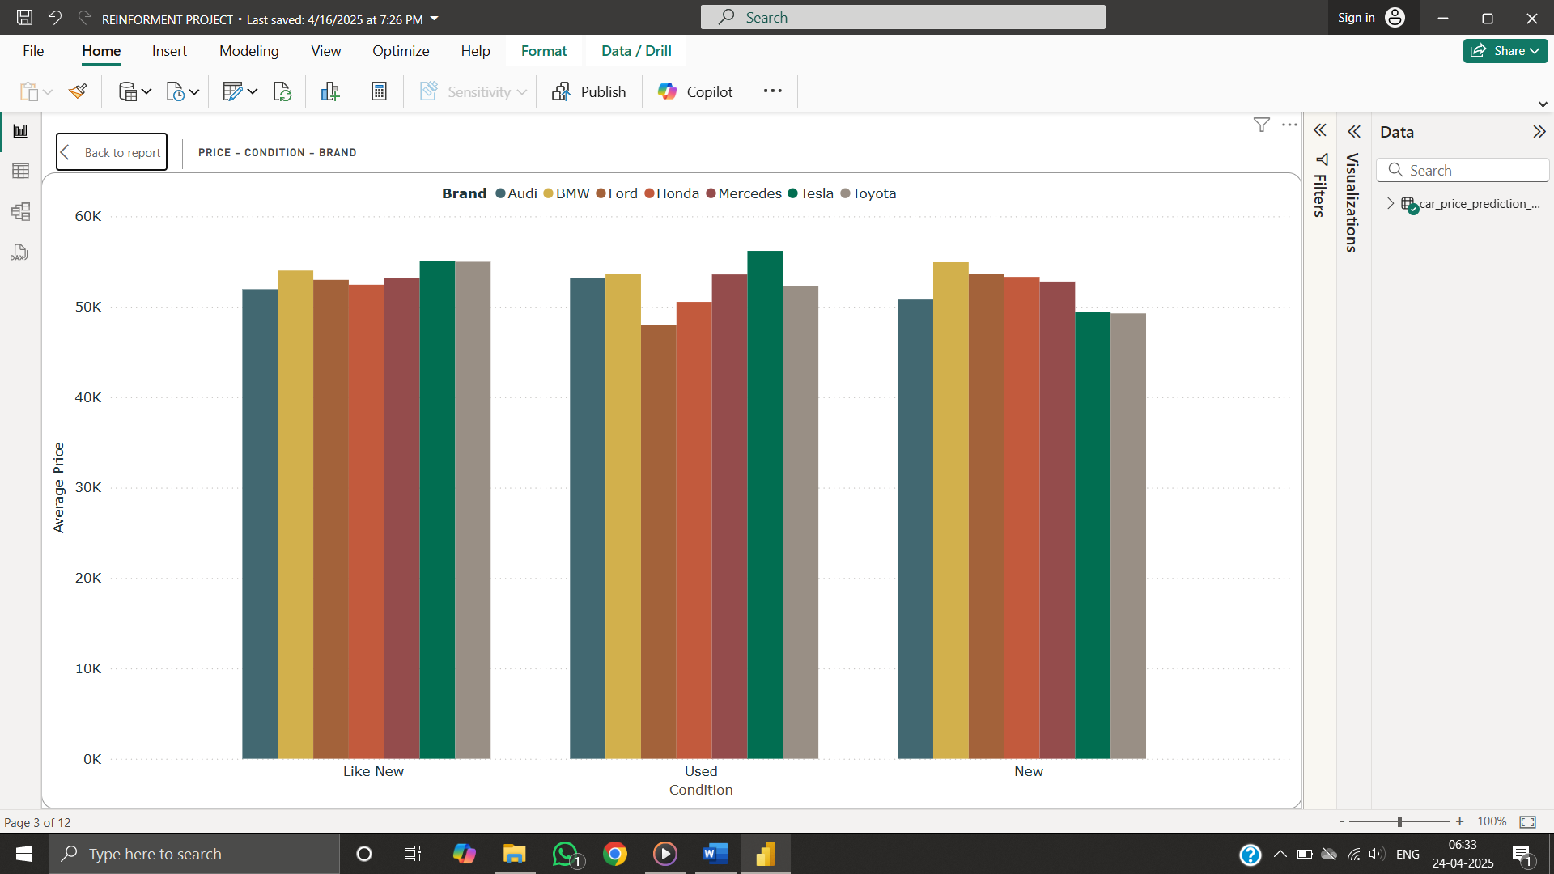

* PRICE-FUEL TYPE-TRANSMISSION:

Comparing Price to Fuel type and Transmission, Diesel and Hybrid fuel type has high pricing in Manual Transmission and lower pricing in Automatic transmission

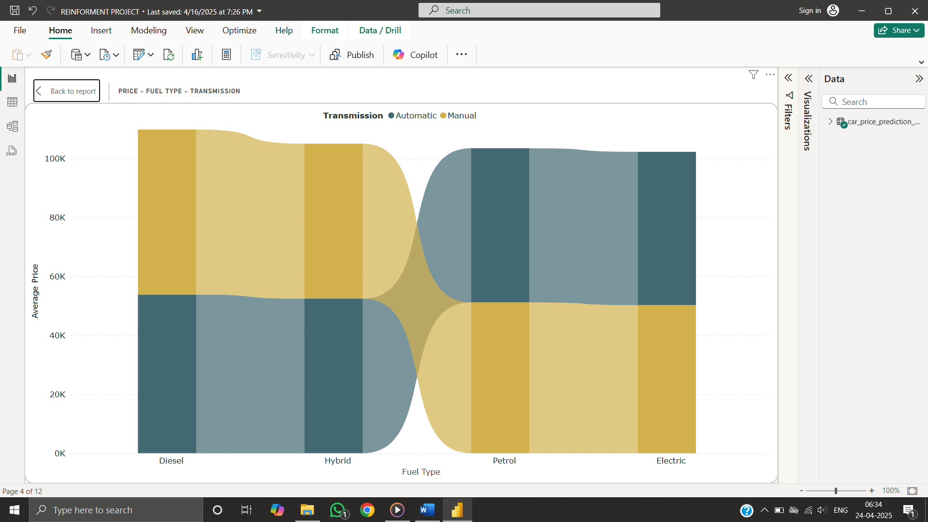

* ENGINE SIZE-FUEL TYPE:

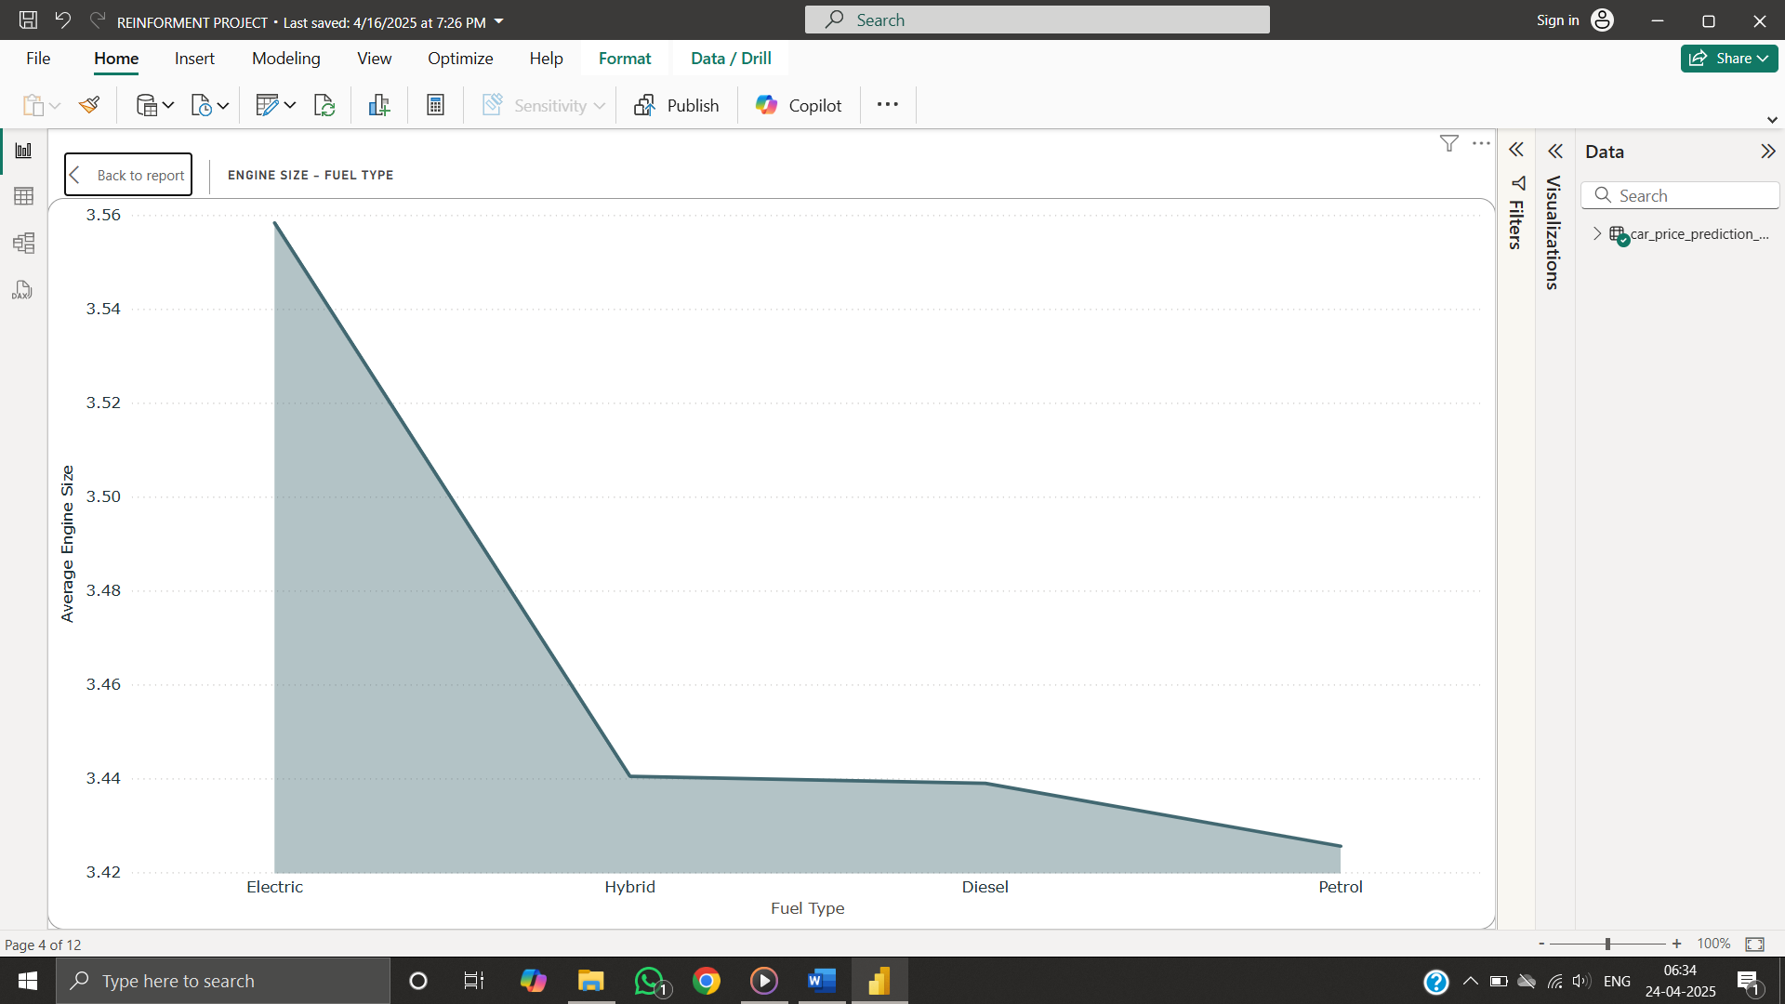

* MILEAGE-BRAND:

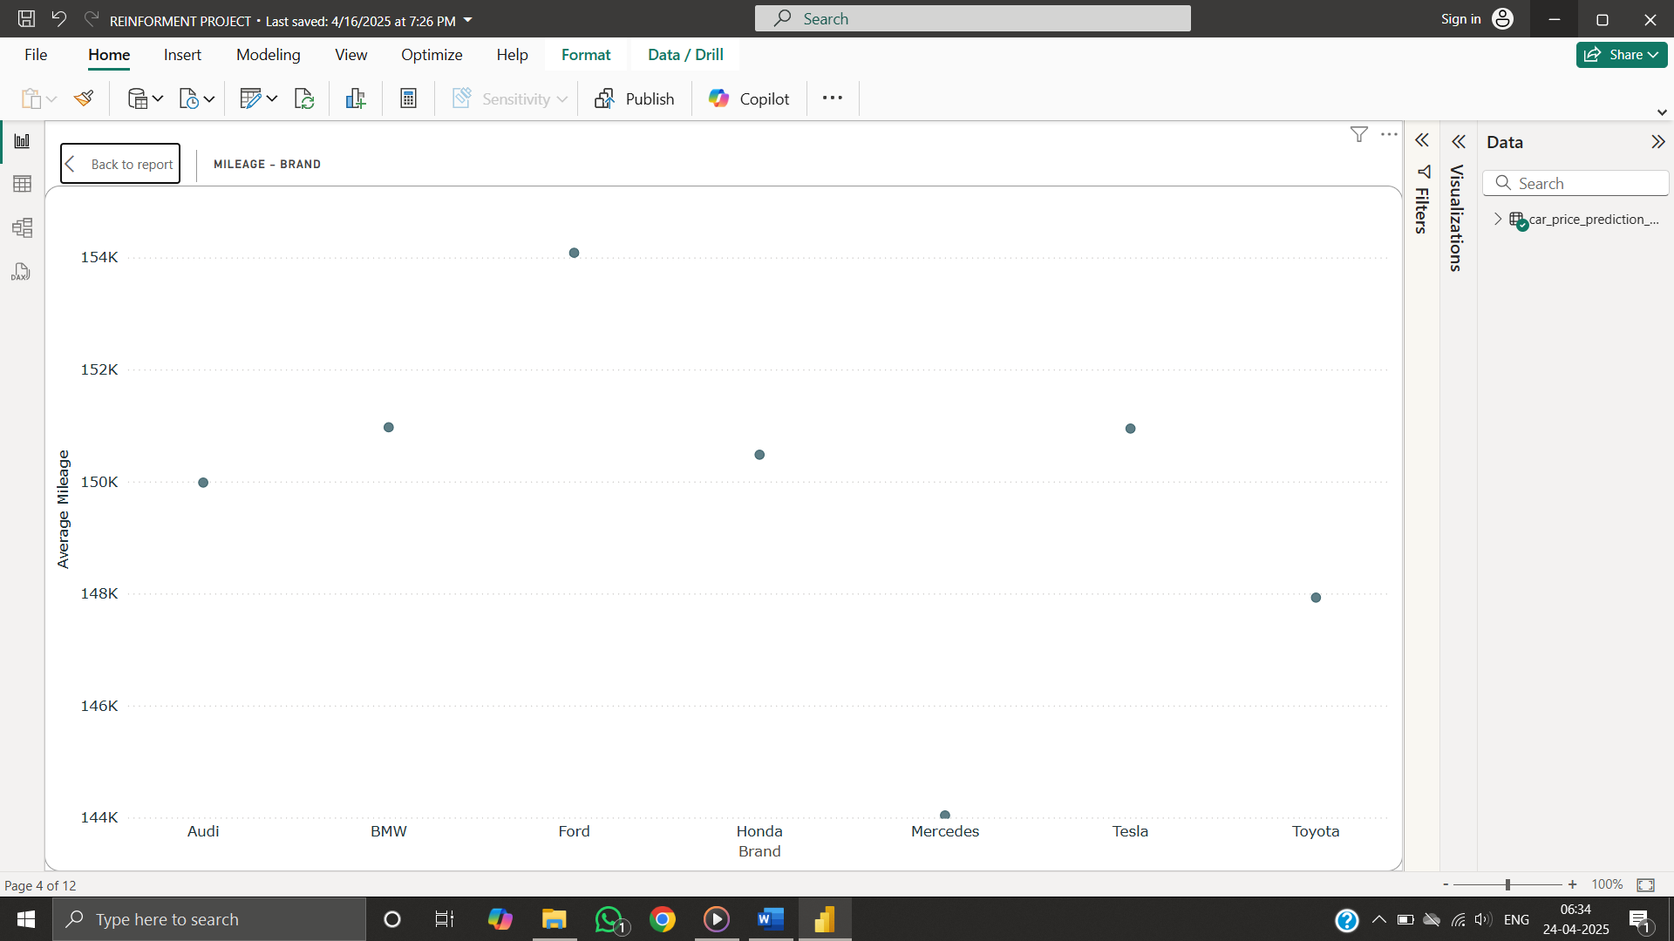

* PRICE-ENGINE SIZE-FUEL TYPE:

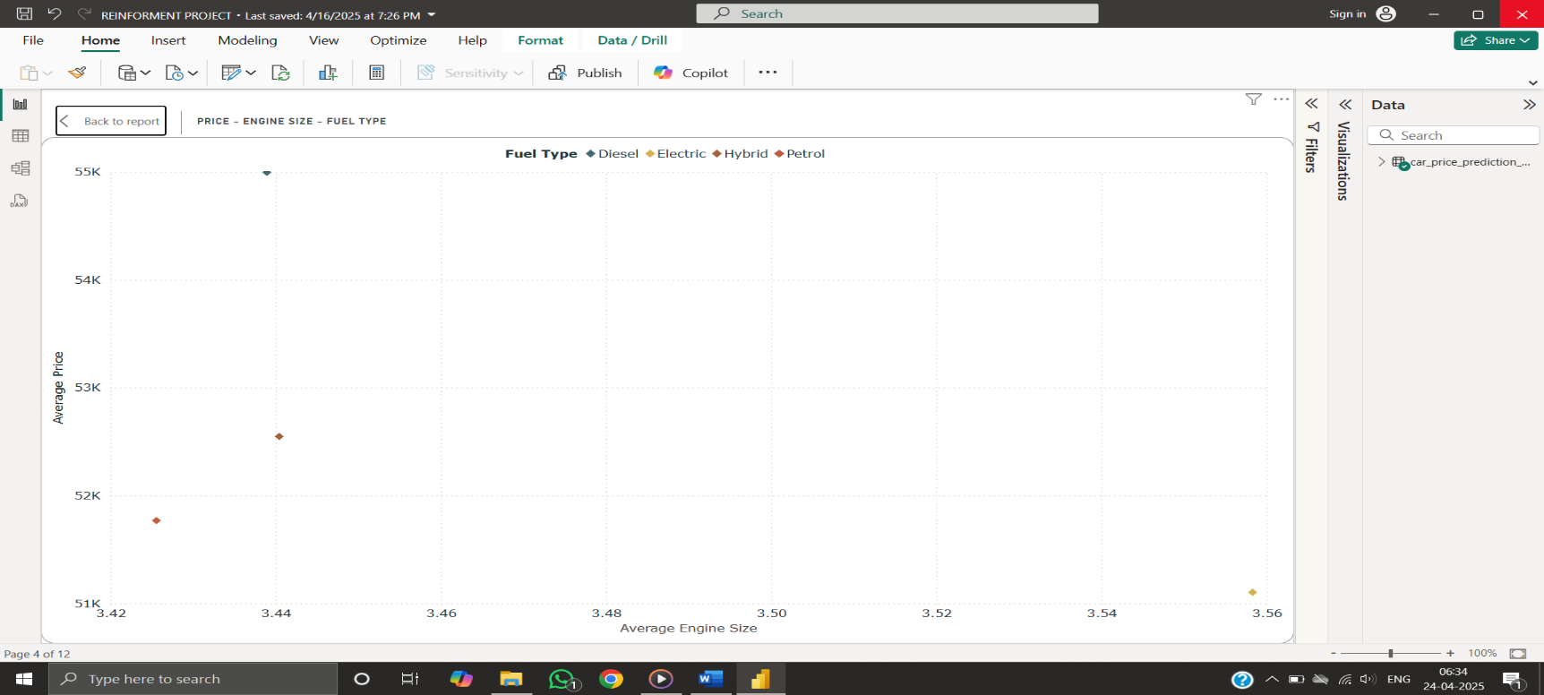

* COUNT OF RECOMMENDATION-YEAR:

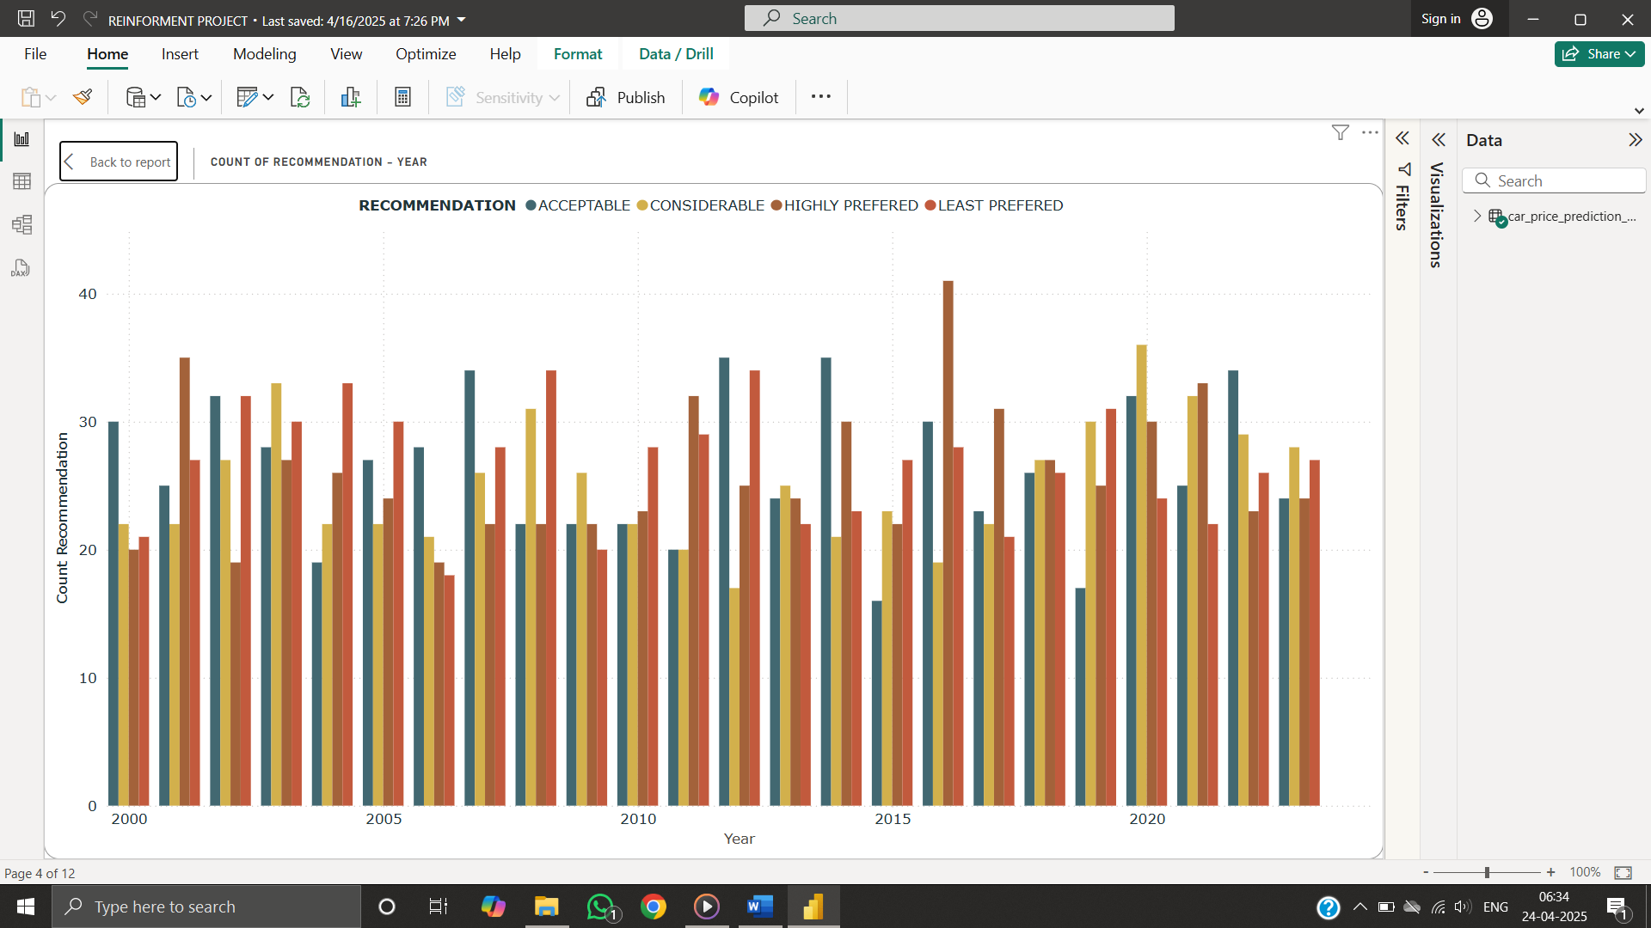

Filters and slicers were added to dynamically explore how various features interact with car price.

**KPI:**

**DASHBOARD:**

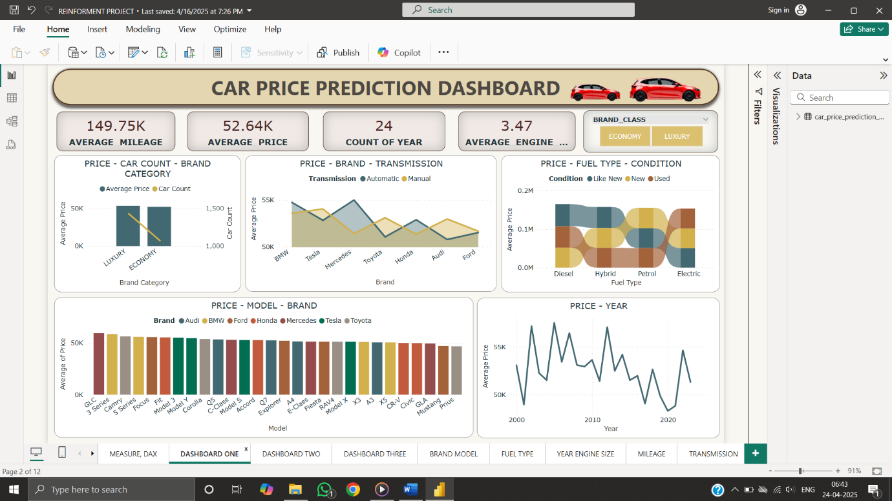

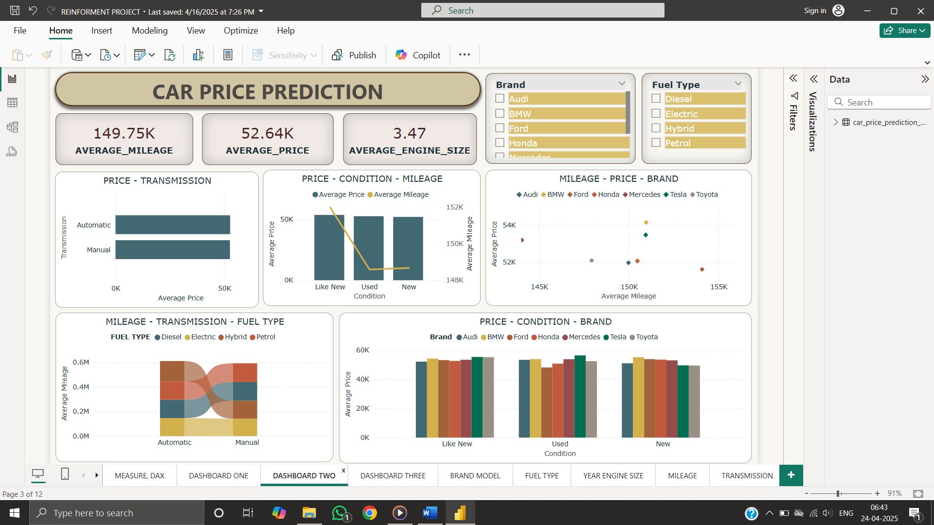

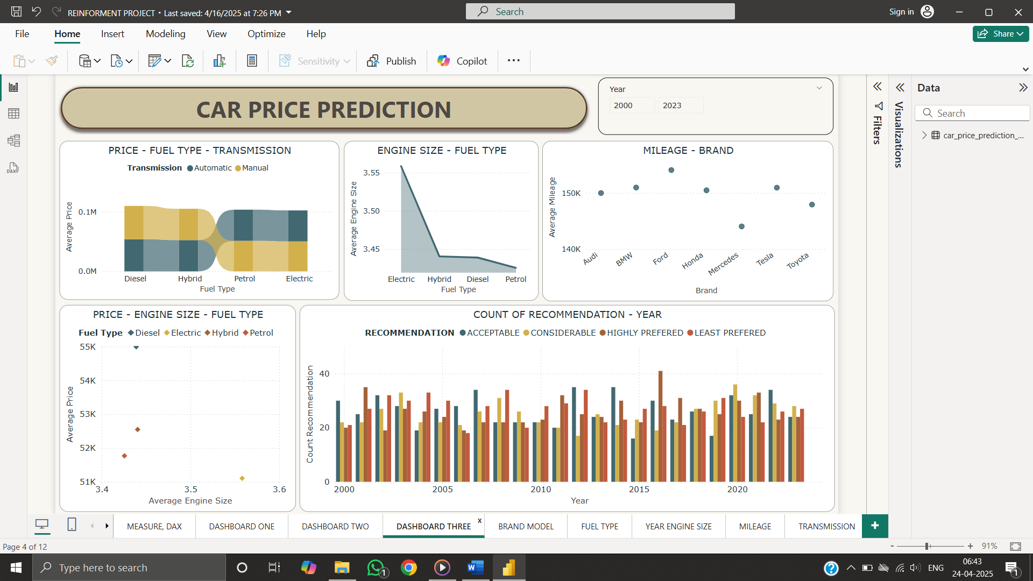

**INSIGHTS:** Based on the visual analysis:

* Brands generate inverse revenue respect to Transmission
* Highest sales - 2005 and lowest sales - 2020
* Automatic cars priced slightly higher than Manual cars
* Like new cars have higher Price and Mileage
* Electric vehicles – higher Engine size - lower Mileage
* Irrespective of Condition BMW - preferred

**CONCLUSION**

Analysis highlights how vehicle characteristics like brand, engine size, and condition have substantial impacts on car pricing. Trends across mileage, year, and fuel type provide a comprehensive overview of what influences market value. Pricing could depends on several other factors -

* + Manufacturing cost
  + Inflation
  + Dealer profit margin
  + Insurance type

**Recommendations**

* Explanation on Brand strength - Price
* Resale explanation help better analysis
* Details on safety features and other amenities
* Customer perspective on preferences over Brands
* Geographic location contribution on Price
* Target newer, fuel-efficient automatic cars

THANK YOU

REPORTED BY

VEENA SRI PM

DATA ANALYTICS AND DATA SCIENCE

RP 33.